11.63: a) The force will be vertical, and must support the weight of the sign, and is 300 N. Similarly, the torque must be that which balances the torque due to the sign’s weight about the pivot, 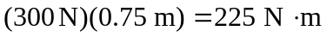. b) The torque due to the wire must balance the torque due to the weight, again taking torques about the pivot. The minimum tension occurs when the wire is perpendicular to the lever arm, from one corner of the sign to the other. Thus, The angle that the wire makes with the horizontal is 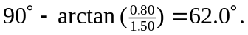Thus, the vertical component of the force that the pivot exerts is (300 N) –(132 N) sin 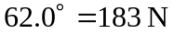and the horizontal force is 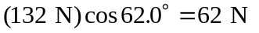, for a magnitude of 193 N and an angle of 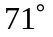 above the horizontal.

